|  |  |  |  |
| --- | --- | --- | --- |
|  | Bansilal Ramnath Agarwal Charitable Trust's  Vishwakarma Institute of Information Technology  **Department of**  **Artificial Intelligence and Data Science** | | |
| Student Name: Mohammad Faiz Nishat Parvej Saiyad | | | |
| Class: TY | Division: A | | Roll No:371034 |
| Semester: V | | Academic Year:2022-23 | |
| Subject Name & Code: Design and Analysis of Algorithms | | | |
| Title of Assignment: **Implement All Pair Shortest paths problem using Floyd's Algorithm.** | | | |
| Date of Performance: | | Date of Submission: | |

**Aim:**

**Implement All Pair Shortest paths problem using Floyd's Algorithm.**

**Problem Statement:**

Implement All Pair Shortest paths problem using Floyd's Algorithm.

**Software Requirements:**

Text Editor: VSCode, Neovim, etc

Environment: Python 3.10

Terminal Emulator

**Background Information:**

**The Floyd Warshall Algorithm:**

The Floyd Warshall Algorithm is for solving all pairs shortest path problems. The problem is to find the shortest distances between every pair of vertices in a given edge-weighted directed Graph.

## **Algorithm:**

* Initialize the solution matrix same as the input graph matrix as a first step.
* Then update the solution matrix by considering all vertices as an intermediate vertex.
* The idea is to one by one pick all vertices and updates all shortest paths which include the picked vertex as an intermediate vertex in the shortest path.
* When we pick vertex number k as an intermediate vertex, we already have considered vertices {0, 1, 2, .. k-1} as intermediate vertices.
* For every pair (i, j) of the source and destination vertices respectively, there are two possible cases.
* k is not an intermediate vertex in shortest path from i to j. We keep the value of dist[i][j] as it is.
* k is an intermediate vertex in shortest path from i to j. We update the value of dist[i][j] as dist[i][k] + dist[k][j] if dist[i][j] > dist[i][k] + dist[k][j]

**Code:**

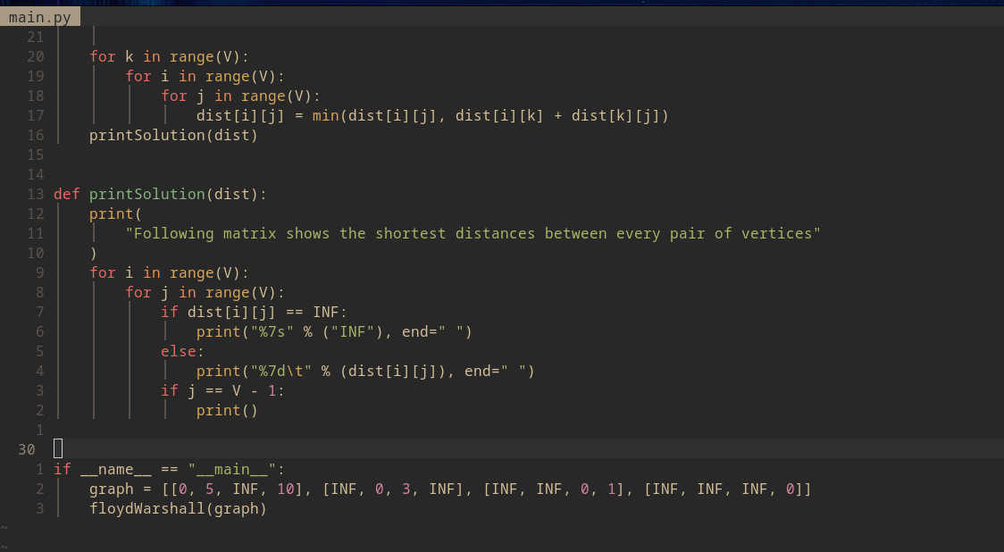

**Output:**

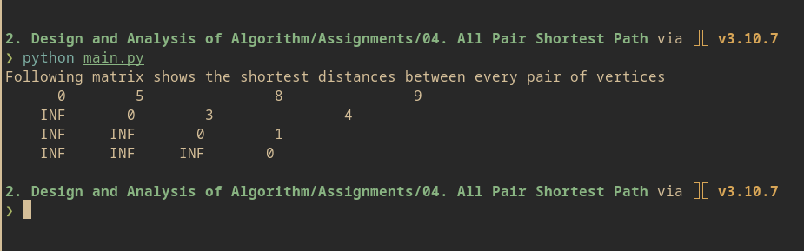

**Conclusion:**

Implemented All Pairs Shortest Path Problem using Floyd Warshall Algorithm.